AI LAB 3 — TASK 1
Manual Trace of BFS and DFS
Name: Abdullah Khan
Roll No: 031
Course: Artificial Intelligence Lab
Lab: 3
1. Objective
To manually trace Breadth-First Search (BFS) and Depth-First Search (DFS) on the original A–G
graph, record the queue/stack state and processed nodes, and verify the final path and visit order.
2. Given Graph and Assumptions
Start node: A | Goal node: G
Graph successor order: A: [B, C], B: [D, E], C: [F], D: [], E: [G], F: [], G: [].
The successor order is followed exactly as given in the lab manual. Search stops when G is
processed.
3. BFS (Breadth-First Search)
BFS uses a queue (First In, First Out). It explores nodes level by level. The queue below is shown
from front to rear. The path stored with each node is shown in parentheses.
Step
Processed node
Queue after processing
Path to node
1
A
[ (A, A) ]
A
2
B
[ (B, A→B), (C, A→C) ]
A → B
3
C
[ (C, A→C), (D, A→B→D), (E,
A→B→E) ]
A → C
4
D
[ (D, A→B→D), (E, A→B→E), (F,
A→C→F) ]
A → B → D
5
E
[ (E, A→B→E), (F, A→C→F) ]
A → B → E
6
F
[ (F, A→C→F), (G, A→B→E→G) ]
A → C → F
7
G
[] (goal processed; stop)
A → B → E → G
BFS visit order: A, B, C, D, E, F, G.
BFS final path: A → B → E → G.
Explanation: BFS processes the shallowest nodes first. It finds the goal at depth 3.
4. DFS (Depth-First Search)
DFS uses a stack (Last In, First Out). To visit the first listed neighbour first, neighbours are pushed
in reverse order. The stack below is shown with the TOP on the left. Duplicate nodes already
processed are skipped.

Step
Processed node
Stack after processing (TOP
first)
Path to node
1
A
[ (B, A→B), (C, A→C) ]
A
2
B
[ (D, A→B→D), (E, A→B→E), (C,
A→C) ]
A → B
3
D
[ (E, A→B→E), (C, A→C) ]
A → B → D
4
E
[ (G, A→B→E→G), (C, A→C) ]
A → B → E
5
G
[ (C, A→C) ] (goal processed;
stop)
A → B → E → G
DFS visit order: A, B, D, E, G.
DFS final path: A → B → E → G.
Explanation: DFS follows one branch deeply before backtracking. Since neighbours are pushed in
reverse order, B is processed before C and D before E.
5. Comparison
Feature
BFS
DFS
Data structure
Queue (FIFO)
Stack (LIFO)
Visit order
A, B, C, D, E, F, G
A, B, D, E, G
Returned path
A → B → E → G
A → B → E → G
Main behaviour
Level by level
Deep branch first
6. Verification with Supplied Code
The manual specifies that BFS and DFS should be checked against the supplied code. For the given
graph and successor order, both return A → B → E → G. Their visit orders differ: BFS processes A, B,
C, D, E, F, G, while DFS processes A, B, D, E, G.
7. Conclusion
BFS searches level by level using a queue, while DFS explores a deep branch using a stack. On the
original A–G graph, both find the same path to G, but they process nodes in different orders. The
visit order and the final path must be reported separately.
Note: This document covers Task 1 only and follows the original A–G graph and trace conventions
in the Lab 3 manual.

ARTIFICIAL INTELLIGENCE LAB — TASK 2
Depth-Limited Search (DLS) and Iterative Deepening DFS (IDDFS)
1. Objective
Implement DLS and IDDFS on the supplied A–G graph. Run DLS at depth limits 1, 2, 3 and 4, and run
IDDFS with maximum depth 4. Report each status and path, explain why limits below 3 do not
reach G, and use a path-local cycle check.
2. Graph Used
A → B, C; B → D, E; C → F; E → G. Nodes D, F and G have no successors.
Start state: A | Goal state: G | Root depth: 0
The goal path in this graph is A → B → E → G, which has depth 3.
3. Code Screenshot
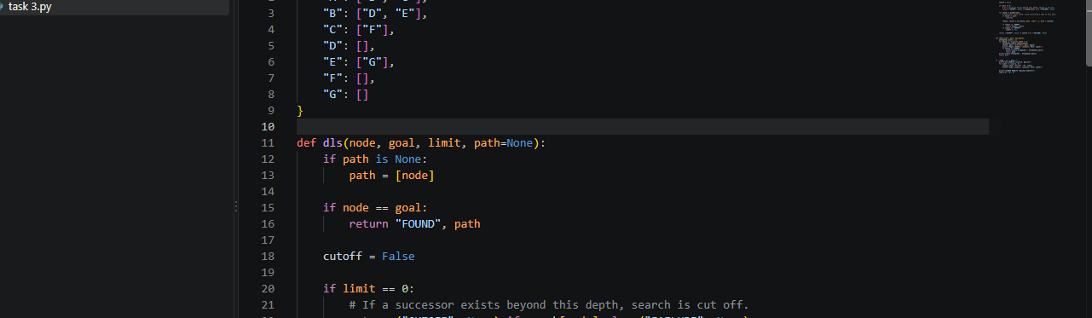
The full runnable Python code is included in Appendix A and the separate task2_dls_iddfs.py file.
4. Program Output Screenshot
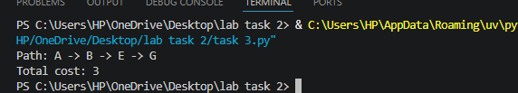
5. Results and Interpretation

Search
Limit
Result
DLS
1
CUTOFF — goal not reached
DLS
2
CUTOFF — goal not reached
DLS
3
FOUND — A → B → E → G
DLS
4
FOUND — A → B → E → G
IDDFS
0, 1, 2, 3
FOUND at depth 3; limits
attempted 0–3
DLS with limits 1 and 2 cannot reach G because the path A → B → E → G requires three edges. At
limits 3 and 4, the goal is found. IDDFS repeats depth-limited search with increasing limits and
stops once it finds the goal at depth 3. Repeated shallow exploration is the trade-off for finding a
shallow goal without choosing one fixed depth in advance.
CUTOFF means the depth bound prevented further exploration; FAILURE means no remaining path
can lead to a goal within the searched branch. The implementation checks for cycles on the current
path rather than using one global visited set across different depth limits.
6. Conclusion
The experiment demonstrates that the supplied goal is three edges from A. DLS succeeds when its
depth limit is at least 3. IDDFS tests increasing limits and finds the path A → B → E → G at depth 3.

ARTIFICIAL INTELLIGENCE LAB — TASK 3
Weighted Graph and Uniform Cost Search (UCS)
1. Objective
Create a weighted version of the supplied A–G graph, run Uniform Cost Search (UCS),
independently verify the returned path cost, and compare UCS with Breadth-First Search (BFS). BFS
prioritizes the number of edges, while UCS prioritizes accumulated path cost.
2. Weighted Graph and Edge Costs
The original vertices and corridors are retained. The C → G corridor is added as a documented
extension for this weighted experiment. The weights are non-negative travel-cost units.
Edge
Cost
Note
A → B
1
Original corridor
A → C
6
Original corridor
B → D
2
Original corridor
B → E
1
Original corridor
C → F
2
Original corridor
E → G
1
Original corridor
C → G
6
Added alternative corridor
3. Algorithm and Implementation
BFS uses a FIFO queue and returns the first route to G by hop count. UCS uses a min-priority queue
and expands the frontier entry with the smallest accumulated cost. The implementation tracks the
best known cost for each node and skips outdated heap entries.
4. Code Screenshot
The screenshot below shows the weighted graph setup and the beginning of the BFS
implementation.

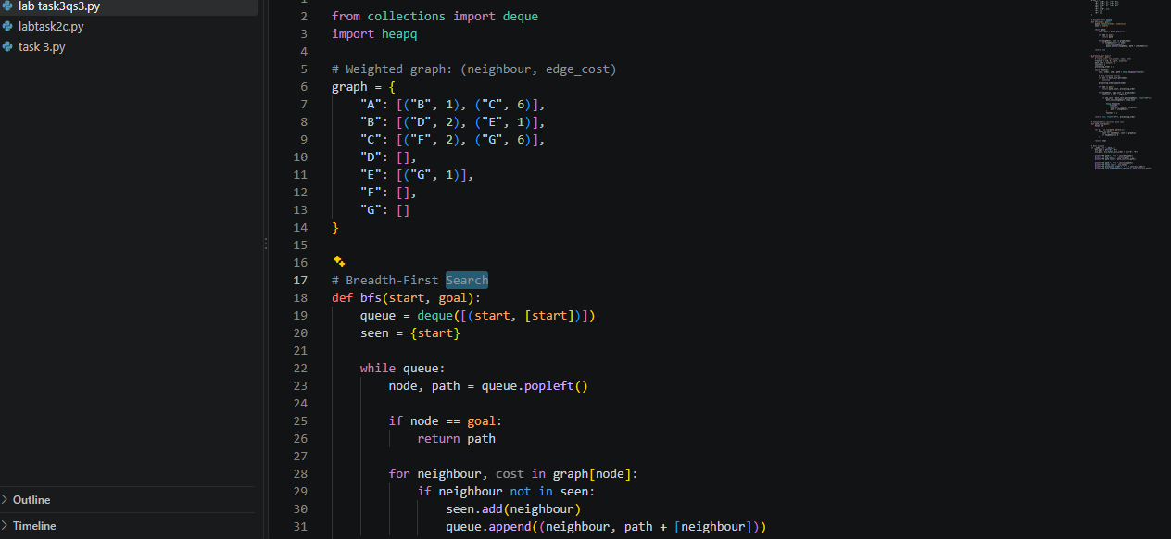
Figure 1. Python code screenshot — graph setup and BFS.
5. Program Output Screenshot
The program was executed, and the output below is included as evidence of the actual run.
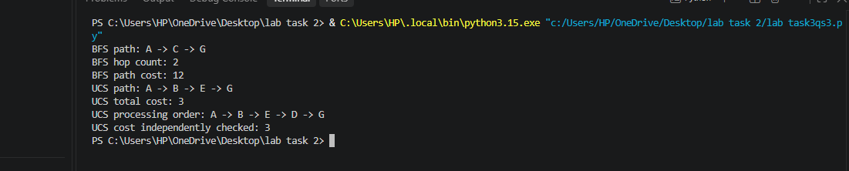
Figure 2. Program output showing BFS and UCS paths, costs, and UCS processing order.
6. Actual Output (Text)
BFS path: A -> C -> G
BFS hop count: 2
BFS path cost: 12
UCS path: A -> B -> E -> G
UCS total cost: 3
UCS processing order: A -> B -> E -> D -> G
UCS cost independently checked: 3
7. Cost Verification and Comparison
BFS route: A → C → G
BFS hop count: 2 edges

BFS total cost: A→C (6) + C→G (6) = 12
UCS route: A → B → E → G
UCS total cost: A→B (1) + B→E (1) + E→G (1) = 3
Independent verification: the edge costs on the UCS route sum to 1 + 1 + 1 = 3.
BFS returns a route with fewer edges, but it does not guarantee minimum cost when edge weights
differ. UCS returns a route with three edges because its total cost is 3, less than the BFS route cost of
12.
8. UCS Processing Order
Actual UCS processing order: A → B → E → D → G. The goal G is included when it is removed from
the priority queue and processed.
9. Conclusion
UCS is suitable when edge costs vary and all costs are non-negative. In this experiment, BFS chooses
A → C → G with two edges and cost 12, while UCS chooses A → B → E → G with three edges and cost
3. Therefore, the route with the fewest edges is not necessarily the cheapest route.

